**BEKKER FAMILY TRUST DEED OF TRUST**

**JOHANNES JACOBUS BEKKER (identity number: 831226 5017 088)**

a major male, married out of community of property currently residing at 5 Gordon Smit Screscent, Dan Pienaar, Bloemfontein, South Africa.

(hereinafter “the founder”)

and

**JOHANNES JACOBUS BEKKER (Identity number: 831226 5017 088)**

a major male, married out of community of property currently residing at 5 Gordon Smit Screscent, Dan Pienaar, Bloemfontein, South Africa.

and

**NICOLAAS ESAIAS DE VILLIERS**

**(Identity number: 760219 5005 083)**

a major male, married out of community of property currently residing at Nr. 7, JD Potgieter Street, Tempe, Bloemfontein, South Africa.

and

**RENATE SYPKENS**

**(Identity number: 850819 0008 080)**

a major female, married out of community of property currently residing at 24 McArthur Street, Fichardtpark, Bloemfontein, South Africa.

**(collectively hereinafter “the trustees”)**

AND the appearers declared that WHEREAS:

1. The founder, in consideration of the affection which he bears towards the beneficiary, is desirous of creating a trust for his benefitaries;

2. The beneficiary has signified her acceptance of the benefits conferred upon her hereunder;

3. The trustees have agreed to accept office as such and to administer the trust herein created.

IT IS HEREBY AGREED THAT:

The Founder hereby donates to the Trustees as and by way of a donation the sum of

R 100.00 (ONE HUNDRED RAND), to be held in trust for the purposes and on the terms and conditions hereinafter set out.

1. DEFINITIONS

In this deed unless the contrary appears from the context the following expressions shall have the following meanings:

1.1 Words importing the singular case shall include the plural case and vice versa and words relating to any gender shall include the other gender and vice versa;

1.2 “the assets”, “the trust assets”, “the trust”, “the capital’, “the trust capital” and the “BEKKER FAMILY TRUST” shall be interchangeable and shall mean and include:

1.2.1 Any Immovable properties the trustees might decide upon;

1.2.2 all other assets and investments at any time or times hereafter ceded or transferred to and accepted by the trustees by way of addition or accretion to the assets hereby settled, whether by the founder or by any other person and either *inter vivos* or by last will;

1.2.3 the assets and investments from time to time representing the aforesaid assets and investments or any of them or any part thereof

as may be occasioned by the application of any of the provisions of

this deed;

1.3 “beneficiary” shall mean the founder’s children and remoter issue (now

living or hereafter to be born) including adopted children;

1.4 “maintenance” with reference to a beneficiary and without restricting the

general meaning thereof, shall mean and include moneys paid by the trust

and received by the beneficiary to cover partially or fully his costs of living, travelling, vacations, medical, dental and similar services, entertainment, tax, general care and provision, welfare, education (including tertiary education), insurance, accommodation, motor vehicles, establishment in a business or a

profession or to maintain him in marriage;

1.5 “the trustees” shall mean and include the original trustees or any persons

assumed by or succeeding them as trustees.

1.6 The headings used in this document are used merely for the sake of

convenience and shall be disregarded when this document is interpreted.

2. NAME OF TRUST

The trust created in terms of this deed shall be known as the **BEKKER FAMILY**

**TRUST** (‘the trust”).

3. TRUST ASSETS TO VEST IN TRUSTEES

The trust assets vest in the trustees in their official capacities as trustees in order

that they may deal with the capital and income of the trust on behalf of the beneficiaries and not to the personal benefit of the trustees qua trustees. At no time shal the trustees deemed to acquire for themselves or their personal account any vested right to the trust assets.

4. TRUSTEES

4.1 The trustees named at the commencement of this deed shall be the first trustees of the trust.

4.2 The power of appointing new trustees shall vest in the founder during his lifetime.

4.3 After the death of the founder the trustees in office from time to time or the surviving trustees shall have the right under a written instrument:

4.3.1 to appoint any person as trustee to take the place of any trustee

dying, resigning or vacating office for any reason:

4.3.2 to assume such additional trustee or trustees as they may deem necessary or desirable;

4.3.3 to change or vary any appointment or assumption so made before effect is given thereto.

4.4 There shall at all times be not less than 3 (THREE) nor more than 5 (FIVE) trustees acting under this deed.

5. WAIVER TO SECURITY

No original or subsequent trustee appointed or assumed under the above provisions shall be required to furnish security to the Master of the High Court of South Africa or any other official in terms of the Trust Property Control Act 57 of 1988 or any other legislation which may now be or which may hereafter become of force and effect; the intent and purpose being that no person who shall at any time be a trustee under this deed shall be required to give any security whatever in connection with or arising out of his appointment as such.

6. ACCOUNTS

The trustees shall keep a true and correct account of their administration of the trust and should it become necessary in terms of legislation or should the trustees decide that the accounts of the trust are to be audited, the trustees shall in their absolute discretion appoint an auditor. The trustees shall submit annually a signed copy of the accounts of the trust to the founder (and to the beneficiaries or their legal

representatives).

7. TRUSTEES’ POWERS

In addition to the powers vested in them by law the trustees may exercise the following powers:

7.1 To retain existing investments

To retain and allow the trust assets or any part or parts thereof to remain in the present state of investment thereof for so long as they may think fit;

7.2. Toinvest .

To invest or reinvest the proceeds of any assets or any moneys of the trust in their hands from time to time in immovable and movable property and in regard to the latter, in government or municipal securities, financial institutions or first mortgage bonds providing, however, that the founder shall have the right to authorise the trustee to invest in securities other than the aforementioned.

7.3

7.4

7.5 To manage the trust assets

discretion may deem fit, PROVIDED such actions are done solely for the benefit of the BEKKER FAMILY TRUST and it’s beneficiaries.

7.6 To repair or improve

To pay out of the capital or, at their discretion, out of the income of the trust assets for any repairs, improvements or other works of whatsoever nature erected on any land included in the trust assets or on any buildings or other structures situated thereon;

7.7 To exercise voting powers

7.8 To compromise and settle

7.9 To consent to any re-organisation, arrangement or reconstruction

To consent to any re-organisation, arrangement or reconstruction of any company the securities of which form, from time to time, the whole or any part of the trust assets and to consent to any reduction of capital or other dealings with such securities as they may consider advantageous or

desirable;

7.10 To surrender shares

To surrender and deliver up any shares forming part of the trust assets for such consideration and upon such terms and conditions as they may approve to any company reducing its capital and to receive such consideration in the form of cash, securities or other assets as may be

agreed upon between them and such company;

7.11 To borrow money

No trustee is allowed to sign any debt agreement or surety that will cause the BEKKER FAMILY TRUST to be bound directly or indirectly by said debt

agreement or suretyship.

7.12 To pay rates, taxes, etc

To pay out of the income or, at their discretion, out of the capital of the trust assets all rates, taxes, duties and other impositions lawfully levied or imposed on the trust assets or income of the trust assets or any part thereof or on any beneficiary hereunder on account of his interest in the trusts hereby created or which may be imposed on the trustees in respect of

matters arising out of the trust;

7.16 To employ agents

To employ accountants, attorneys, agents, brokers, or such professional or other assistants as they may consider necessary to transact all or any business of whatsoever nature required to be done pursuant to this trust deed and to pay all such fees, charges and expenses so incurred as a first charge, and they shall not be responsible for the default of such accountants, attorneys, agents, brokers, professional or other assistants or for any loss

occasioned by such employment;

7.17. Todetermine questions

To determine all questions and matters of doubt which may arise in the course of their management, administration, realisation, liquidation, partition or

winding-up of the trust assets;

7.18 To open and operate a banking account

To be empowered to open and to operate a banking account or accounts in the name of the trust (either the trustees themselves or a person or persons authorised by them).

7.19 To reimburse themselves for expenses incurred

To reimburse themselves and pay and discharge out of any income accruing from the trust, all expenses which may be incurred by them in or about the execution of the trust and powers conferred upon them by this trust deed;

7.20 To charge the cost of secretarial services

To have any secretarial services, which they consider necessary for the administration of the trust, carried out at the cost of the trust;

7.21 To pay costs

To pay out of the capital or income of the trust assets all expenses (including legal fees) incurred in the formation of the trust;

7.22 To enter into contracts of suretyship

No trustee is allowed sign any debt agreement or surety that will cause the BEKKER FAMILY TRUST to be bound directly or indirectly by said debt agreement or suretyship.

t

o

7.23 To engage in legal proceedings

To institute or defend legal proceedings and to sign all deeds, powers of attorney and other documents that may be necessary in the premises;

7.24 To execute documents

With regard to any immovable property or mortgage bond at any time forming part of the trust assets, to execute any act or deed relating to the alienation, partition, exchange, transfer, mortgage, hypothecation or otherwise, in any deeds registry, mining titles office or other public office dealing with servitudes,. usufructs, limited interests or otherwise; and to make any applications, grant any consents and agree to any amendments, variations, cancellations, cessions, releases, reductions,

substitutions or otherwise generally relating to any deed, bond or document

Tian . tP

7.25 To accept further gifts

7.26

7.27 General investment

7.28 Special dispensations for trustees and beneficiaries

the purpose of paying the cost of acquisition and/or the premiums in respect of any insurance policy as aforesaid;

7.29 To determine income

To be entitled to treat as income any periodic receipts although received

from wasting assets, and

amortisation of the same.

shall not be required to make provision for the

They shall also be entitled to determine in such

manner as they

shall be treated

may consider fit what shall

as capital in respect of any

be treated as income and what

liquidation, dividend or return of

capital in the

the trust fund

case of companies whose shares are being held as portion of by the trustees; and generally to decide any question which may

arise as to how much constitutes capital and how much constitutes income by apportioning in such manner as they may consider fit;

7.30 To pay in specie or cash

In making payment at any time to any beneficiary of any portion of the trust fund in terms of this deed, the trustees shall be entitled to make any such payment either in cash or in specie or partly in cash and partly in specie. The trustees’ valuation of any asset distributed by them in specie in terms hereof shall be final and binding on all interested parties. For the purpose of this clause the word “specie” shall be deemed to include any capital asset at

7.31

The trustees may during the trust period pay or apply the income of the trust assets for the maintenance, education or benefit of all or any one or more exclusively of the others or other of the beneficiaries in such shares and manner and upon such conditions as the trustees shall in their sole and

absolute discretion think fit provided that:

7.31.1. The trustees in deciding what portion of the income is to be paid or applied for the purpose aforesaid, shall have regard to the age of any beneficiary, his reasonable requirements and generally to the

circumstances of the case;

7.31.2 The trustees may pay any income to any person, school or university whatsoever to be applied for any of the above purposes without being obliged to see that such income is so applied for any

such purpose;

7.31.3. While any beneficiary is a minor, the trustees shall have the power to pay any such income to the parents or guardian of such minor for his maintenance, education or benefit and = shall not themselves be personally bound to see to the application thereof.

7.32 Power to apply capital for the advancement or benefit of a beneficiary

The trustees may during the trust period, in such manner as they in their absolute discretion deem fit, pay or apply any capital of the trust for the advancement or benefit of any person who may become entitled to such capital or of any share thereof, notwithstanding that such person will only become entitled thereto contingently on his or her attaining any specified age or subject to a gift over on his or her death under any specified age or that the interest of such person is liable to be defeated by the exercise of a power of appointment or revocation or to be diminished by the increase of the class to which such person belongs and such payment or application may be made notwithstanding the occurrence of any other event

provided that:

7.32.1

7.32.2

7.33

7.34

7.35.1

7.35.2

11.1

Tia

12. REMUNERATION

Remuneration payable to the trustees, shall be 2% (TWO PERCENT) per annum on all income accrued and collected and shall be payable at such times as the trustees shall from time to time determine. Upon termination of the trust as hereinafter provided, the trustees shall be entitled to a distribution fee equal to 2% (TWO PERCENT) of the total value of the trust assets distributed to the

beneficiary in terms of this trust deed.

13.FEES FOR PROFESSIONAL SERVICES RENDERED

Any attorney, accountant or broker acting as a trustee under this deed shall be entitled for his own benefit or for the benefit of any firm or company of which he may be a member, to charge normal fees for professional services rendered to the trust or in connection therewith (in addition to his normal remuneration).

14. INDEMNITY

14.1 The trustees shall be indemnified out of the trust fund against all claims of whatsoever nature that may be made upon them arising out of the exercise or purported exercise of any of the powers hereby conferred upon them subject, however, to the provisions of section 9 of the Trust Property Control Act 57 of

1988.

14.2 If the trustees bona fide make any payment to any person whom they assume to be entitled thereto under the terms of this deed and it is subsequently found that some other person or persons is or are entitled thereto hereunder, the trustees shall nevertheless not be responsible for the

moneys so paid.

15.INCOME TO BENEFICIARIES

Pending the distribution of the trust assets as hereinafter provided, none of the income of the trust shall be deemed to be attributable to the share or the prospective or contingent share of any beneficiary but shall be held as a whole by the trustees, to pay from time to time to the beneficiaries hereinbefore defined or any one or more of them, such sum or sums as the trustees may, in their sole and absolute discretion, consider desirable, without any obligation to maintain equality as between the beneficiaries, for his maintenance or generally for such purposes as

Ut el, Ay

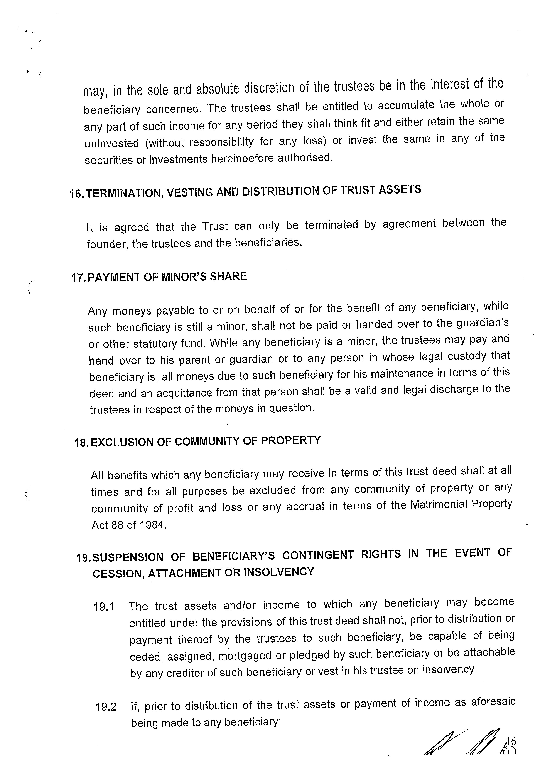

19.2.3. He commits an act of insolvency or is declared insolvent or assigns his estate for the benefit of his creditors; or

19.2.4 He becomes incapable of managing his own affairs,

then, in each case, the contingent right of that beneficiary to any share of the trust assets and/or income shall be suspended and shall remain vested in the

trustees.

19.3 The trustees shall apply the trust assets and/or income for the maintenance of that beneficiary or his spouse or for the maintenance of the lawful children of that beneficiary.

20.PAYMENT TO BENEFICIARY MAY BE IN CASH OR KIND

Payments to any beneficiary under this trust deed may be made by the trustees either by delivery of assets of the trust or in cash as they in their sole and absolute discretion shall determine. The trustees shall have the right to make payment to any particular beneficiary or beneficiaries by delivery or transfer of assets or to pay cash in lieu of assets to any other beneficiary or beneficiaries. The trustees shall determine the valuation of such assets delivered or to be delivered or transferred to any beneficiary or beneficiaries and such valuation shall be unchallengeable by the beneficiary or beneficiaries to whom payment is made and by all other beneficiaries

or persons affected thereby.

21. LOSS OF OFFICE

The office of a trustee shall be vacated:

21.1 If he resigns by written notice to his co-trustees; or

23. AMENDMENT OF DEED

23.1 The founder during his lifetime, with the consent of the majority of the trustees and, following his death, the majority of the trustees, may revise or amend this trust deed provided that such revision or amendment does not constitute any revocation of the trust. The trustees may further amend or revise this trust deed in the event of any legislation necessitating such amendment or revision to comply therewith. The indemnity referred to in clause 14 above shall also be applicable mutatis mutandis in respect of any

damages suffered as a result of the said revision or amendment.

23.2 The Protector shall be:

Ut OAM

24. CONSTRUCTION OF DEED

This deed shall be construed and have effect in all respects as a settlement constituted under the laws of the Republic of South Africa and the trusts and provisions of this deed shall operate in accordance with such laws. The courts of the

Republic of South Africa shall have

and matters relative to this deed or

exclusive jurisdiction to determine all questions

arising out of it. Headings of clauses shall be

deemed to have been included for purposes of convenience only and shall not affect the interpretation of the trust.

25. ACCEPTANCE OF CLAUSE

AND the appearers respectively declared that:

25.1. Founder to be bound

The founder shall be irrevocably bound by the terms and conditions set out in this deed;

25.3 Acceptance by trustees

The trustees hereby accept their appointment as trustees subject to the terms and conditions set out in this deed.

THUS DONE AND EXECUTED by the appearers on the date aforementioned at BLOEMFONTEIN before me, the notary, and in the presence .of the undersigned

witnesses.

SIGNED and DATED at BFA on this Q DAY of Ade UST 2022.

AS WITNESSES: ”

My pz .

JOHANNES JACOBUS BEKKER

FOUNDER

SIGNED and DATED at i EN on this }Q__ DAY of A UC US | 2022.

AS WITNESSES: AS LO

JOHANNES JACOBUS BEKKER TRUSTEE

BP a"

SIGNED and DATED Words this 2 DAY of Bg ew/ 2022.

AS WITNESSES:

NICOLAAS ESAIAS DE VILLIERS TRUSTEE

SIGNED and DATED at 5 Fh onthis 30° DAY of Ane WS) 2022.

AS WITNESSES:

RENATE SYPKENS

TRUSTEE

21